**Category I-RestNTravel™ Pillows:**

1. **For NECK REST**
   1. **7 x 7” (150 gms) Jute/Cotton Cover Square Pillow (100₹)**
   2. **7 x 12” (250 gms) Jute/Cotton Cover Round Pillow (200₹)**

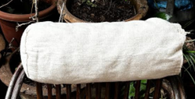

For **BACK REST & SEATING**:

1. **10 x 10” (300 gms) Jute/Cotton Cover Square Pillow (150₹)**
2. **14 x 14“(450 gms) Jute/Cotton Cover Square Pillow (200₹)**

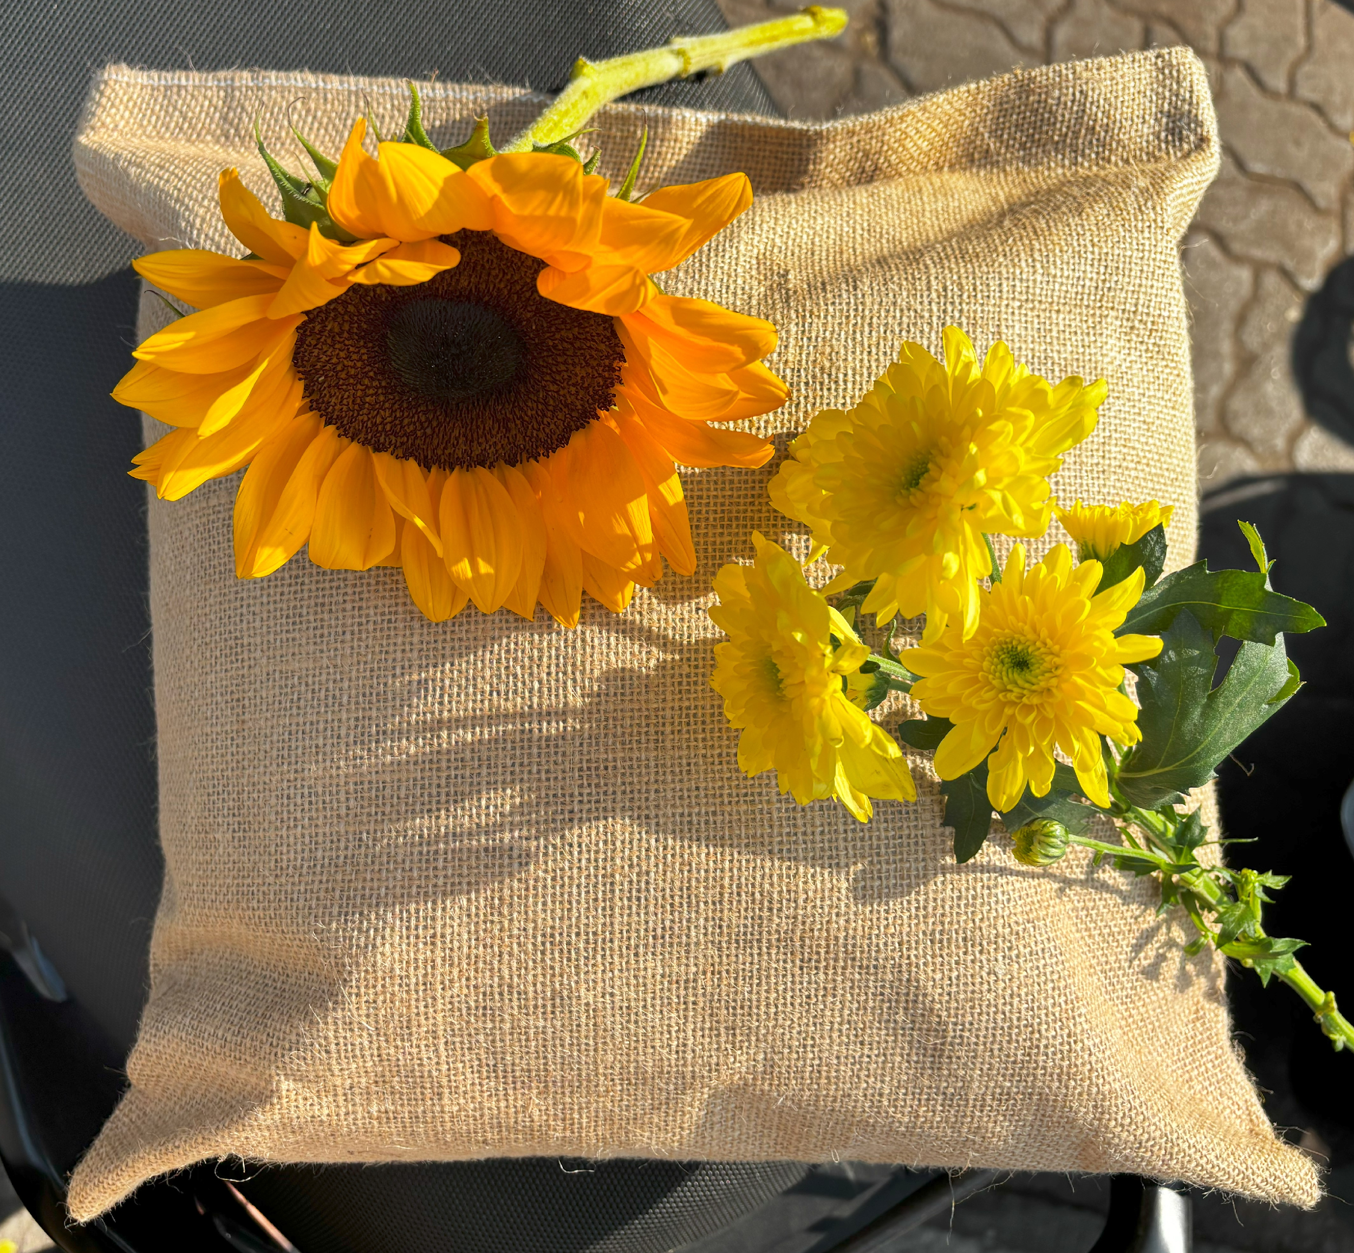

1. **20 x 26” (750 gms) Jute/Cotton Triangular Pillow (300₹)**

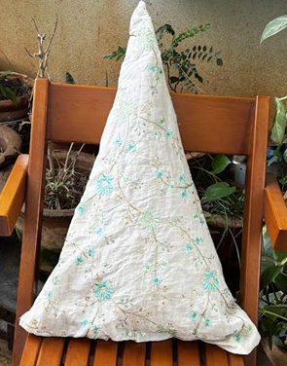

For **SLEEPING**:

1. **14 x 22 “(750 gms) Jute/Cotton Cover Rectangular Pillow (250₹)**
2. **16 x 22” (850 gms) Jute/Cotton Cover Rectangular Pillow (300₹)**
3. **16 x 27” (1000 gms) Jute/Cotton Cover Rectangular Pillow (350₹)**

**Category II-RestNTravel™ Mattresses:**

Single 5’x2.5’ (1500₹)

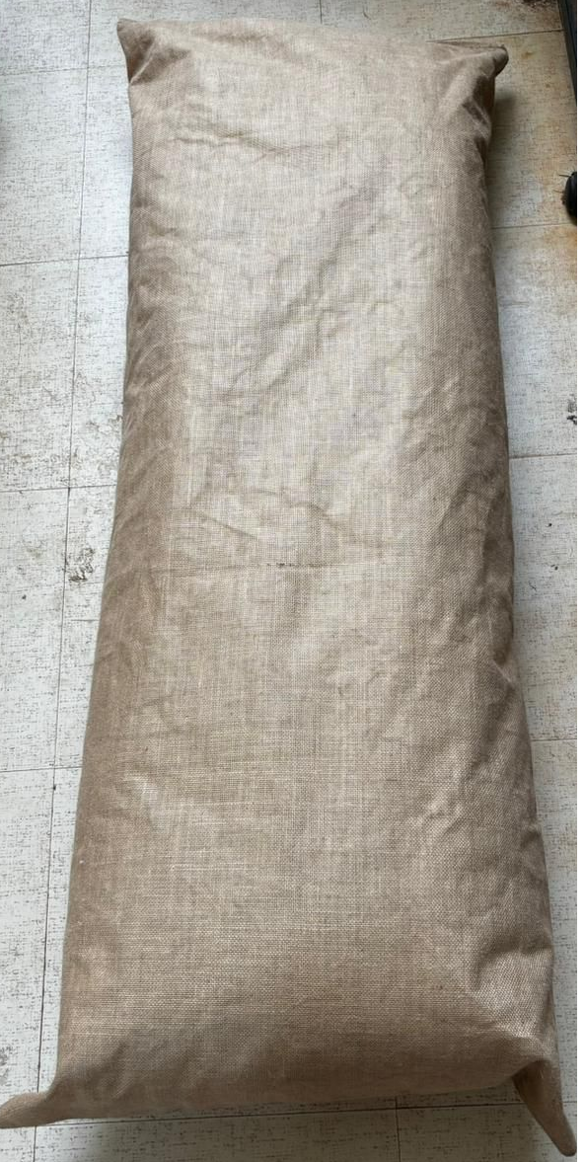

Double 6’x5’ (2000₹)

**Category III-RestNTravel™ Quilts:**

Single 5’x2.5’ (1500₹)

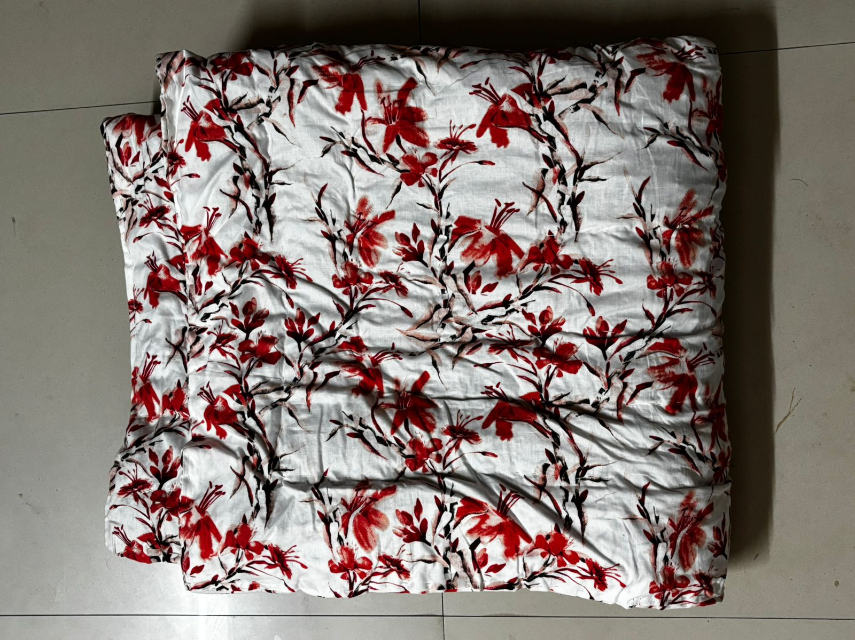

Double 6’x5’ (2000₹)

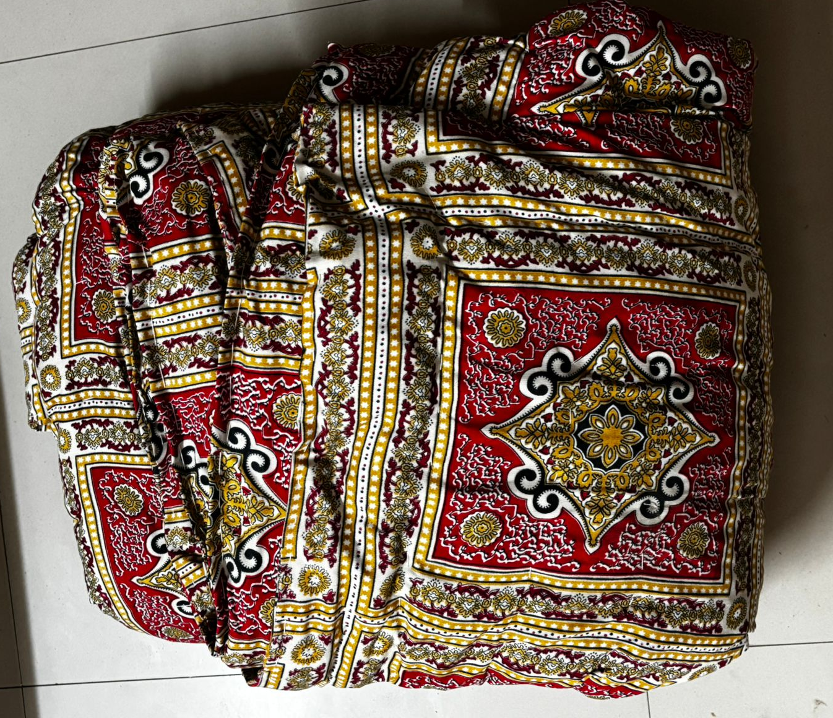

**Category III-RestNTravel™ Bean bag**

5’x4’ (1500₹)

